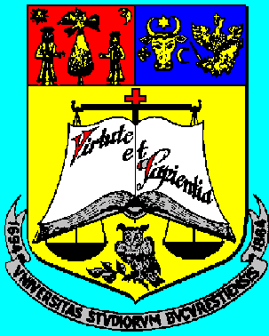
University of Bucharest, Faculty of Mathematics and Computer Science
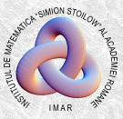
Simion Stoilow Institute of Mathematics of the Romanian Academy

“Algebra Workshop”
in honour of Professor Mirela Ștefӑnescu
on the occasion of her 75th birthday

December 10, 2016, Bucharest

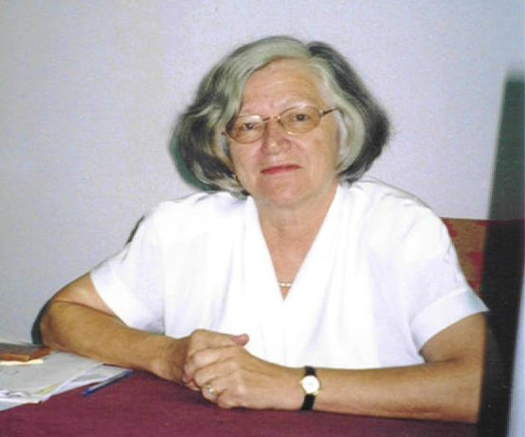
Speakers:
• Daniel Bulacu (Bucharest)
• Lászlό Márki (Budapest)
• Claus Michael Ringel (Bielefeld)
• Freddy Van Oystaeyen (Antwerp)

Organizers: Toma Albu and Sorin Dӑscӑlescu
Venue: | University of Bucharest, Faculty of Mathematics and Computer Science,
Venue: | str. Academiei 14, Stoilow Lecture Room (first floor)

If you are interested to attend, please send an e-mail message to Toma.Albu@imar.ro

